World War II
Japanese Internment Camps
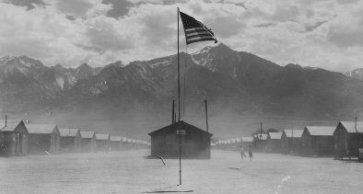
After the Japanese attacked Pearl Harbor the United States declared war on Japan and entered World War II. Not long after the attack, on February 19, 1942, President Roosevelt signed an executive order that allowed the military to force people of Japanese ancestry into internment camps. Around 120,000 Japanese-Americans were sent to the camps.
What were internment camps?
Internment camps were sort of like prisons. People were forced to move into an area that was surrounded by barbed wire. They were not allowed to leave.
Why did they make the camps?
The camps were made because people became paranoid that Japanese-Americans would help Japan against the United States after the Pearl Harbor attack. They were scared that they would sabotage American interests. However, this fear was not founded on any hard evidence. The people were put in the camps based only on their race. They had not done anything wrong.
Who were sent to the internment camps?
It is estimated that around 120,000 Japanese-Americans were sent to ten camps spread out around the Western United States. Most of them were from west coast states like California. They were divided into three groups including the Issei (people who had immigrated from Japan), the Nisei (people whose parents were from Japan, but they were born in the U.S.), and the Sansei (third generation Japanese-Americans).

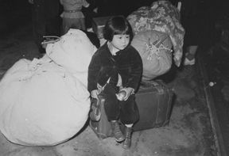
Were there children in the camps?
Yes. Entire families were rounded up and sent to the camps. Around a third of the people in the camps were school aged children. Schools were set up in the camps for the children, but they were very crowded and lacked materials like books and desks.
What was it like in the camps?
Life in the camps wasn't very fun. Each family typically had a single room in tarpaper barracks. They ate bland food in large mess halls and had to share bathrooms with other families. They had little freedom.
Were Germans and Italians (the other members of the Axis Powers) sent to camps?
Yes, but not at the same scale. Around 12,000 Germans and Italians were sent to internment camps in the United States. Most of these people were German or Italian citizens who were in the U.S. at the start of World War II.
The Internment Ends
The interment finally ended in January of 1945. Many of these families had been in the camps for over two years. Many of them lost their homes, farms, and other property while they were in the camps. They had to rebuild their lives.
The Government Apologizes
In 1988, the U.S. government apologized for the internment camps. President Ronald Reagan signed a law that gave each of the survivors $20,000 in reparations. He also sent each survivor a signed apology.
Interesting Facts about the Japanese Internment Camps
- Despite the unfair and harsh treatment, the people in the camps were fairly peaceful.
- After being freed, the internees were given $25 and a train ticket home.
- The camps have been called by a number of names including "relocation camps", "internment camps", "relocation centers", and "concentration camps."
- People at the camps were required to fill out a "loyalty" questionnaire to determine how "American" they were. Those that were determined to be disloyal were sent to a special high security camp called Tule Lake in Northern California.
- Around 17,000 Japanese-Americans fought for the United States military during World War II.

Source: https://www.ducksters.com/history/world_war_ii/japanese_interment_camps.php

