Emergency Kit Items (recommended by ready.gov)

- Soap, hand sanitizer and disinfecting wipes to disinfect surfaces
- Food (at least a several-day supply of non-perishable food)
- Pet food and extra water for your pet
- First aid kit
- Sleeping bag or warm blanket for each person
- Paper cups, plates, paper towels and plastic utensils
- Matches in a waterproof container
- Plastic sheeting and duct tape (to shelter in place)
- Complete change of clothing appropriate for your climate and sturdy shoes
- Moist towelettes, garbage bags and plastic ties (for personal sanitation)
- Wrench or pliers (to turn off utilities)
- Feminine supplies and personal hygiene items
- Fire extinguisher
- Cash or traveler's checks
- Water (one gallon per person per day for several days, for drinking and sanitation)
- Infant formula, bottles, diapers, wipes and diaper rash cream
- Dust mask (to help filter contaminated air)
- Battery-powered or hand crank radio and a NOAA Weather Radio with tone alert
- Local maps
- Flashlight
- Cell phone with chargers and a backup battery
- Prescription medications.
- Extra batteries
- Non-prescription medications such as pain relievers, anti-diarrhea medication, antacids or laxatives
- Whistle (to signal for help)
- Manual can opener (for food)
- Prescription eyeglasses and contact lens solution
- Important family documents such as copies of insurance policies, identification and bank account records saved electronically or in a waterproof, portable container
- Paper and pencil
- Books, games, puzzles or other activities for children

Directions: Imagine you have all the items on the emergency kit list on the other side of this paper. Your task is to make 2 emergency kits – one for a tornado and one for a hurricane. However, only 5 items will fit in each kit, and you cannot use the same item for both kits – each kit has to have different items. How would you put the kits together? Also, rank the items you chose in the order of importance.
Emergency Kit Items
Tornado | Hurricane
1. ___________________________________  2. ____________________________________  3. ___________________________________  4. ____________________________________  5. ___________________________________  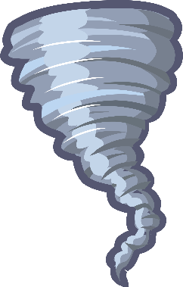 | 1. ___________________________________  2. ____________________________________  3. ___________________________________  4. ____________________________________  5. ___________________________________  

