Name _________________________________________________________ Date _________________________

Key Vocabulary

Ecosystem ________________________________________________________________

_________________________________________________________________________

Autotrophs/Producers ______________________________________________________

_________________________________________________________________________

Herbivore ________________________________________________________________

_________________________________________________________________________

Consumer ________________________________________________________________

________________________________________________________________________

Carnivore ________________________________________________________________

_________________________________________________________________________
Decomposer ______________________________________________________________

_________________________________________________________________________
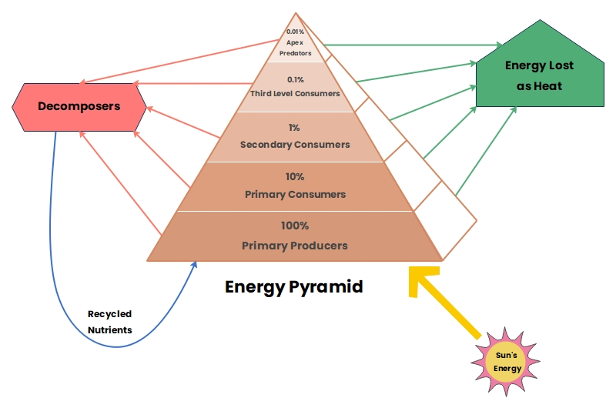

Biome: ___________________________________________________________
Directions: Label the levels of the eco-pyramid below. Then research 2-5 living things that would go in each pyramid level for your assigned biome. Feel free to draw pictures if you wish.
