Cell Notes
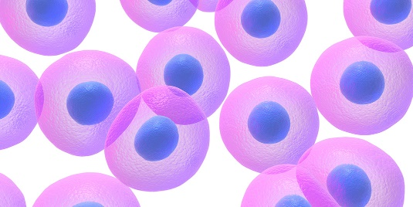
Cell ___________________________________________

________________________________________________

________________________________________________
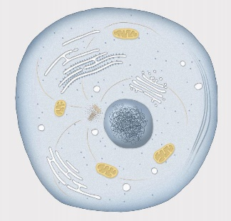

Cytoplasm _______________________________________

________________________________________________

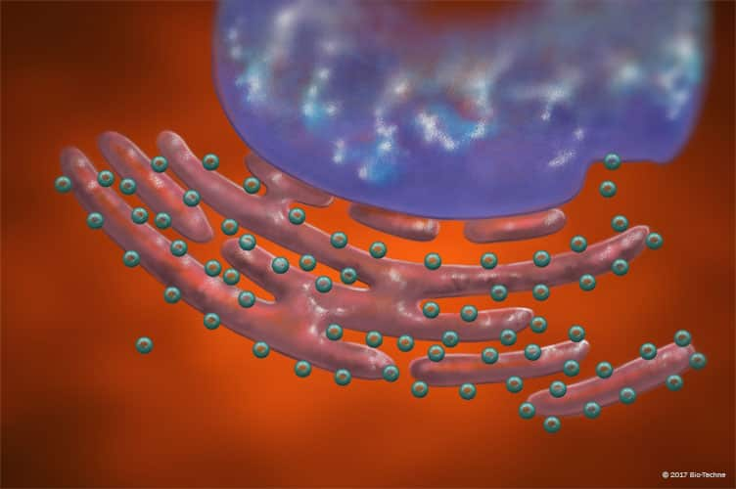

Ribosomes ______________________________________

_________________________________________________

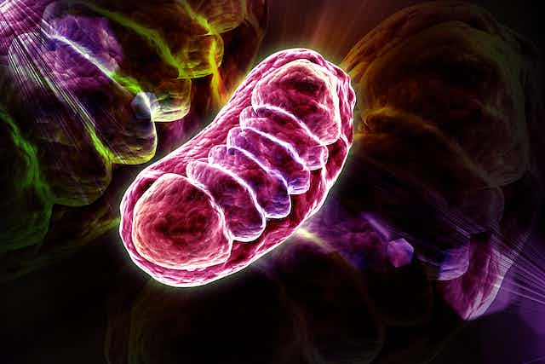
Mitochondria ______________________________________

__________________________________________________

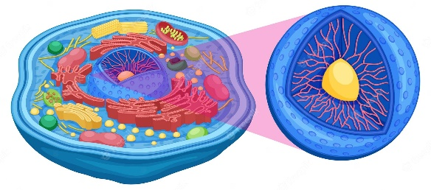
Nucleus __________________________________________

_________________________________________________

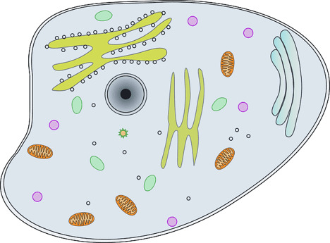

Cell Membrane ______________________________________

Directions: Write the cell vocabulary word that best matches each clue. Words will be used more than once!

1. It controls what the cell does _________________________________

2. It is the smallest unit of a living thing _________________________________

3. They make proteins _________________________________

4. It fills up the inside of the cell _________________________________

5. It determines what goes in and out of the cell _________________________________

6. It is sometimes described as the “powerhouse” of the cell _______________________

7. It is made of a jelly-like substance _________________________________

8. All living things are made up of these _________________________________

9. It is the control center of the cell _________________________________

10. They look like small little dots _________________________________

11. It covers the outside of the cell _________________________________

12. It gives the cell energy _________________________________

Directions: Draw your own picture of a cell. Include all 6 of the cell vocabulary words in it.

