Foundations of Designing for Equity and Access for ALL Learners
Summer/Fall 2021

Application period – July 15 - August 13
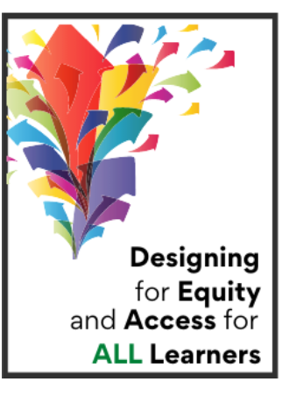
Part 1: Introduction to Equity, Access, and Effective Teaching and Learning online session – Self- paced - August 16 - September 7
a)Produce a Video Introduction on Flipgrid
b)Define equity and create a new lens to view ourselves, our learners, and our learning environments
b) Explore equity in learning and what it means for you and your students through a variety of resources
c) Address learning needs through creating a stimulating learning environment
d) Complete Assignment #1 - Exploring Learning Preferences and their Applications
(3 hours)
Part 2: Let’s Meet Together - Informal Classroom Assessments, Understanding the Learner/Learning Process
September 9, 2021 7:00-8:30pm OR September 10, 2021 9:00-10:30
(1.5 hours)
Part 3: Assignment #2 - Equity Observation Tool and Infusing Equity into your classroom or program
(3 hours)
Part 4: Let’s Meet Together - Introduction to Universal Design for Learning, Effective Instructional Practices
September 29, 2021 - 9:00-10:30 am OR 7:00-8:30pm
(1.5 hours)
Part 5: Final Assignment - UDL and Discussion Board
(1 hour)
Total of 10 hours of professional development

