Designing for Equity and Access for ALL Learners
To best reflect current research and needs of our learners training is available to all Illinois Adult Education teachers in Designing for Equity and Access for ALL Learners. This training, formerly known as Special Learning Needs, is part of the Instructional Staff Professional Pathways already in place.
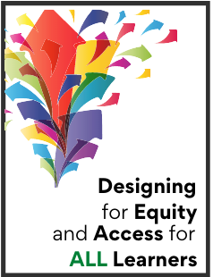
The Southern Illinois Professional Development Center in collaboration with the Illinois Community College Board and the Adult Education Professional Development Network was excited to announce this transformation.
Special Learning Needs training has been in place in Illinois since 1999 and has undergone multiple modifications to reflect new research, progression in technology, and the evolving needs of our students. This current transformation provides a rebranding of the training to reflect our need to ensure equity and access. As a part of the push for equity, infusion of Universal Design for Learning will be emphasized in the training. Some of the key components of the original SLN training will remain, including effective instructional practices and designing instruction with learner needs in mind.
All Standards Proficient credentialed instructors will see connections to their
already-completed training. Participants will be encouraged to build on their prior knowledge and completed work in Standards Proficient training.
Training opportunities include:
Foundations of Designing for Equity and Access for ALL Learners (asynchronous and synchronous online sessions with opportunities for application exercises with students – 10 hours of professional development)
Institute for Designing for Equity and Access for ALL Learners (asynchronous and synchronous online sessions with opportunities for application exercises with students – 15 hours of professional development and resulting in a credential of Specialist in Equity)
Update for Prior Completers of the Institute to Credential Special Learning Needs Resource Specialists (asynchronous and synchronous online sessions with opportunities for application exercises with students – 5 hours of professional development) For the many prior completers of the former training, an updated training will be provided to allow them to refresh their training and earn the new credential.
Look for more information coming soon about the training, and check the Excellence in Adult Education website.

