Name: _____ANSWER KEY______

Ratio, Proportion, & Percents Application Activity

Directions: Use what you’ve learned about ratios, proportions, and percents to solve the following problems. Show your work. If you get stuck, use words to write down what you did and what you think you might do next. Don’t leave anything blank.

- What is the ratio of black to white squares? Write your answer as both a fraction (x/y) and colon (x:y).

Fraction: ____7/13_______ Colon: __7:13___________

- Ralph bought a 12 oz can of lemon seltzer that had 3% lemon juice. How many ounces of the can was lemon juice?

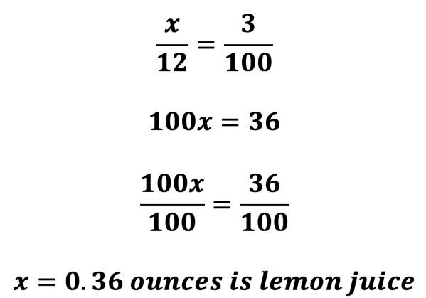

- Abbie got 14 out of 27 questions right on her economics test. She needed an 85% or better to get a B in the class. Will Abbie get a B? Why or why not?

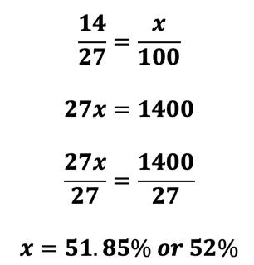
No, Abbie will not get a B because 52% is less than 85% and she needed 85% on this test to get a B in the class.

- What is 9 percent of 432?

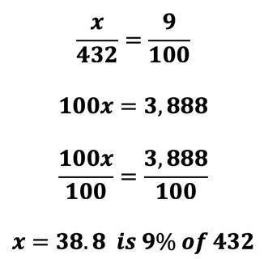

- Kathleen came in 4,974th place out of 36,203 riders on her most recent Peloton ride. What percentage is this to the nearest whole percent?

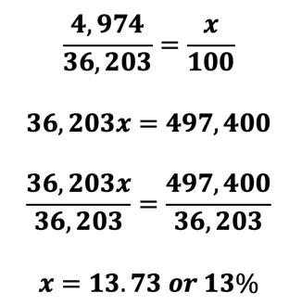

- Karly’s team hires one team lead for every 14 project managers. If there are 40 project managers, how many team leads will Karly’s team need?

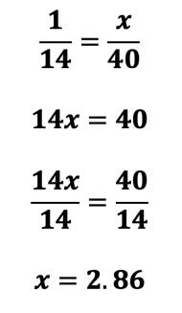
Since we cannot hire .86 of a person, we need to round UP to the next whole number, which means that Karly’s team will need 3 team leads.

