Nutrition Facts Label:
Ratios and Proportions

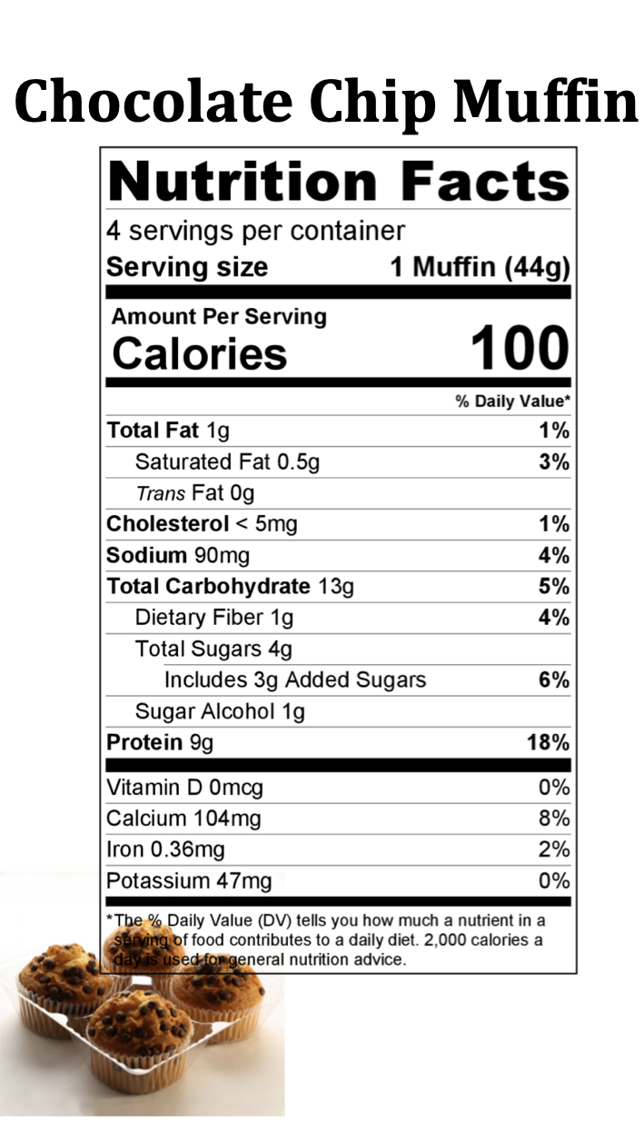
Directions: Read each label and determine the total amount of nutrients in the entire package using ratios.

#1

- How many calories are in one serving?

- How many servings per container?

- How many calories are there per container?

- How many grams of protein are there per serving?

- How many grams of protein are there per container?

- How many grams of sugar are there per serving?

- How many grams of sugar are there per container?
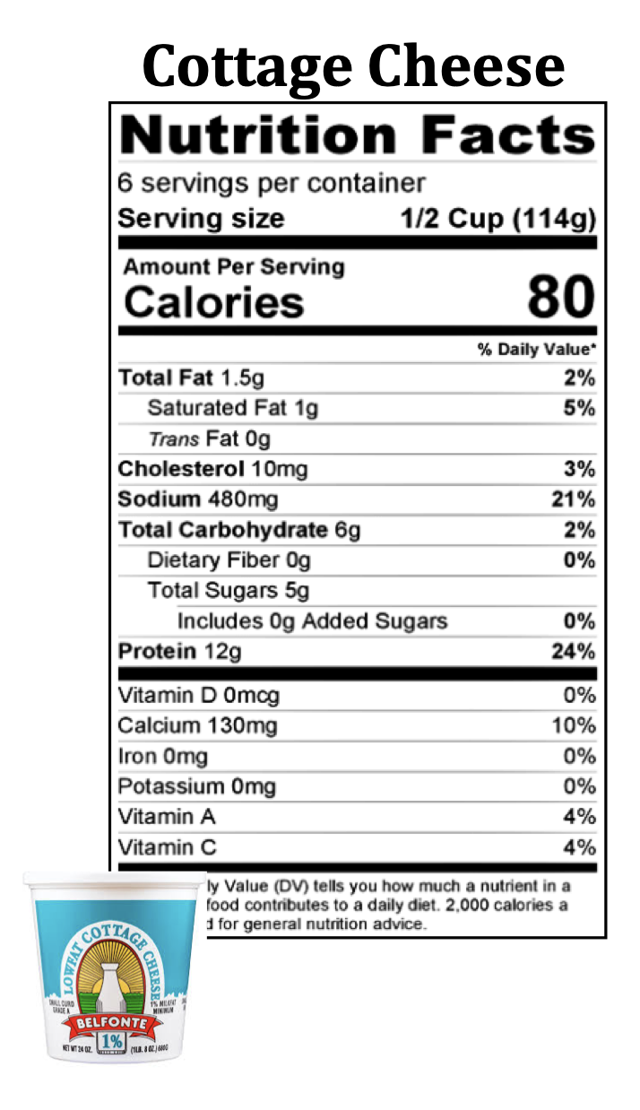
#2

- How many calories are in one serving?

- How many servings per container?

- How many calories are there per container?

- How many grams of protein are there per serving?

- How many grams of protein are there per container?

- How many grams of sugar are there per serving?

- How many grams of sugar are there per container?

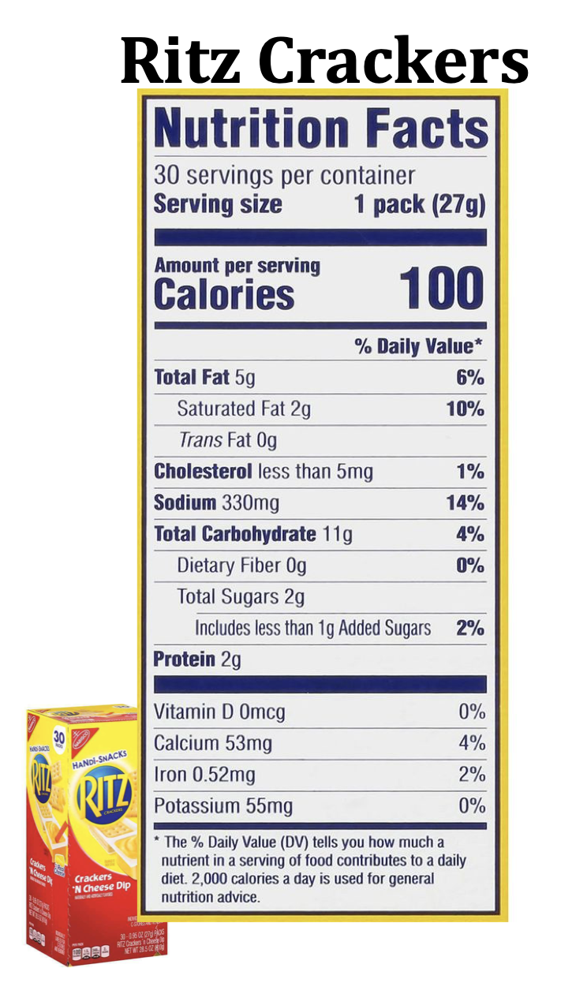
#3

- How many calories are in one serving?

- How many servings per container?

- How many calories are there per container?

- How much fat is there per serving?

- How much fat is there if you eat 2 servings?

- How much sugar is there per serving?

- How much sugar is there in 2 servings?

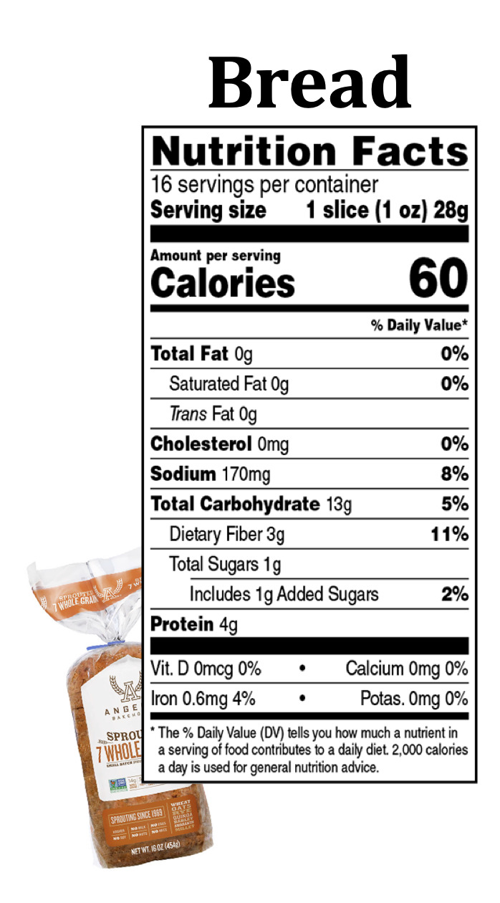
#4

- How many calories are in one serving?

- How many servings per container?

- How many calories are there per container?

- How much sodium is there per serving?

- How much sodium is there in 2 servings?

- How much dietary fiber is there per serving?

- How much dietary fiber is there in 4 servings?

Images taken from National Agriculture in the Classroom https://cdn.agclassroom.org/media/uploads/2018/08/18/Nutrition_Fact_label_cards.pdf

