Nutrition Facts Label:
Ratios and Proportions

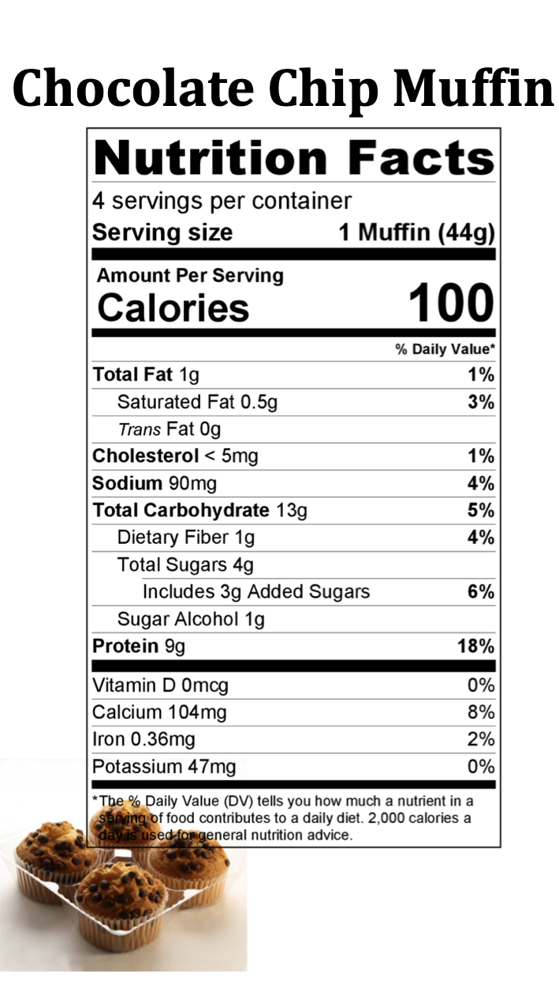
Directions: Read each label and determine the total amount of nutrients in the entire package using ratios.

#1

- How many calories are in one serving?
100
- How many servings per container?
4
- How many calories are there per container?
400
- How many grams of protein are there per serving?
9
- How many grams of protein are there per container?
36
- How many grams of sugar are there per serving?
4
- How many grams of sugar are there per container? 16
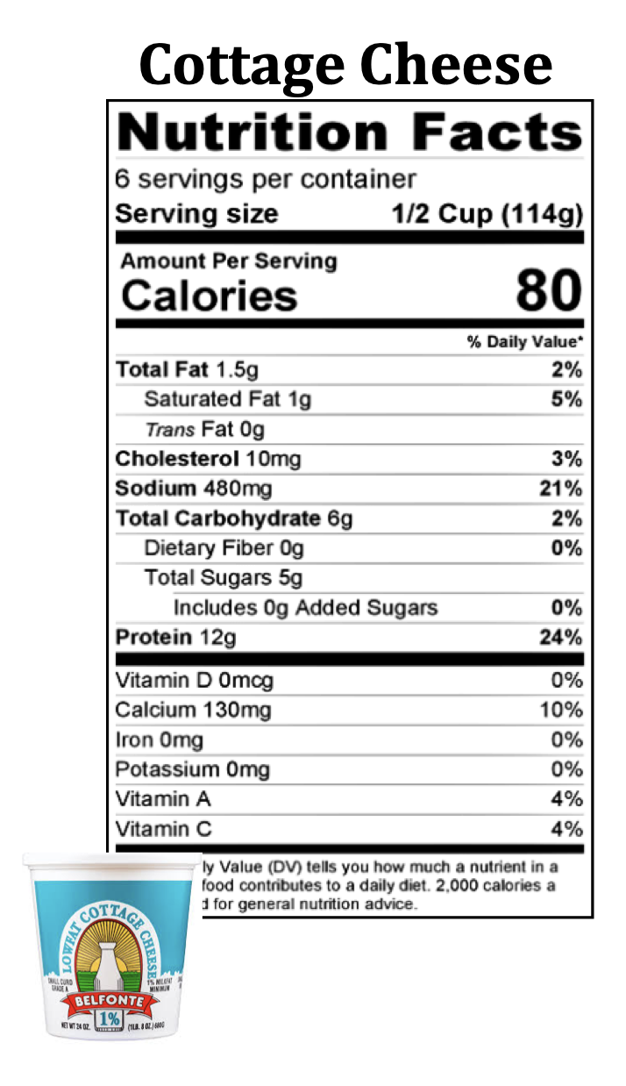
#2

- How many calories are in one serving?
80
- How many servings per container?
6
- How many calories are there per container?
480
- How many grams of protein are there per serving?
12
- How many grams of protein are there per container?
72
- How many grams of sugar are there per serving?
5
- How many grams of sugar are there per container?
30

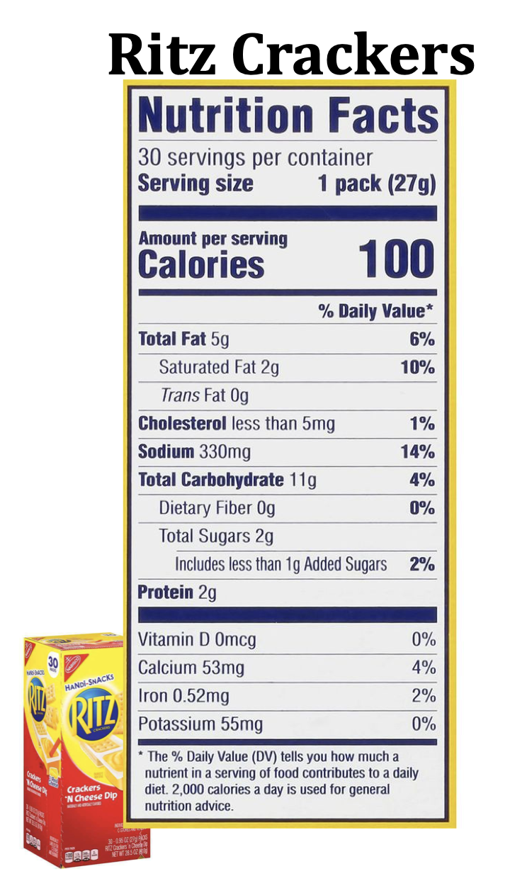
#3

- How many calories are in one serving?
100
- How many servings per container?
30
- How many calories are there per container?
3,000
- How much fat is there per serving?
5
- How much fat is there if you eat 2 servings?
10
- How much sugar is there per serving?
2
- How much sugar is there in 2 servings?
4

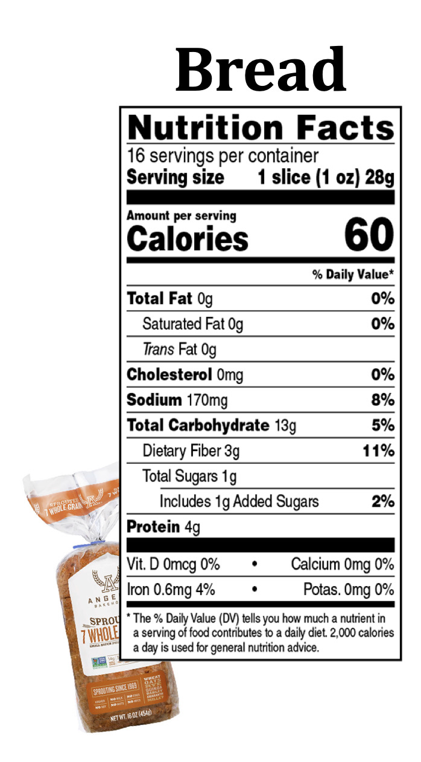
#4

- How many calories are in one serving?
60
- How many servings per container?
16
- How many calories are there per container?
960
- How much sodium is there per serving?
170
- How much sodium is there in 2 servings?
340
- How much dietary fiber is there per serving?
3
- How much dietary fiber is there in 4 servings?
12
Images taken from National Agriculture in the Classroom https://cdn.agclassroom.org/media/uploads/2018/08/18/Nutrition_Fact_label_cards.pdf

