Choice Boards
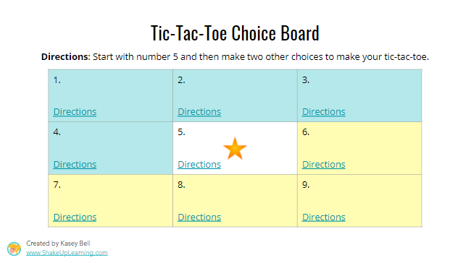

Giving students choices allows for individual differences in learning, encourages autonomy, and provides the learner the power to choose “how” to learn. It’s an effective instructional practice whether you’re in-person or virtual. It gives students opportunities to practice and master concepts taught in class. Choice Boards is an engaging strategy to help simplify lesson planning and addresses learning variability.
Choice boards are graphic organizers that comprise of different amounts of squares. Each square is an activity. The activities help students learn or practice a primary concept, while allowing them a choice. Students can be instructed to choose one or more of these activities to complete. They can progress from one activity to another either in an organized or random order.

Click here to get a google doc template

The following are tips to using Choice Boards to design for variability:

- When creating the boards be sure to have activities that cater to every learning style such as visual, auditory, read-write and kinesthetic.
- Boards can be created for weekly tasks, homework, projects and even assessments. Detailed instructions and requirements can be given for each task. An extra credit slot can be included to encourage students to better their learning.
- Tic-Tac-Toe: Encourage students to perform a set of three activities so that it forms a Tic-Tac-Toe. Students can choose these activities horizontally, vertically or diagonally. In this method the “FREE CHOICE” square can be in the middle.

Use of Choice Boards help to improve student motivation, engagement and learning by empowering them to learn to the best of their ability.

Credit: ShakeUpLearning.com

