“I Have / Who Has”
These cards are used for the “I Have/Who Has” activities in Lesson 3. Notice that there are two versions provided. The first version is the original and is part of the whole-class activity in the lesson plan.
INSTRUCTOR SETUP
Human Number Line/Original version:
3. In order to hand out fewer cards and still keep the sequence going, take from the last numbers of B2 and A2, alternatively and in that order.
4. If playing in person, the number line will be a yarn string or clothesline with pins to hold the cards. Alternative number lines could be a makeshift number line made of masking tape, placed on a wall, the floor, or a long table. Mark the endpoints and an accurate one-half mark before starting the activity.
Call and Compare version:
3. The cards are marked so that A cards call for their corresponding B cards (i.e.: A1 calls for B1).
4. Students with non-starred cards will listen for their fraction to be called. You should hand out a card with a star for every non-starred card. If there are an odd number of students, use the first card yourself to model for students
ORIGINAL VERSION (W/ NUMBER LINE)
Each student is given an “I have, Who has?” card. They should immediately start working out the fraction’s value. The gold-starred card begins the call sequence. This first caller hangs their card on the number line in the appropriate space and says “I have __ ; who has __?” filling in the blanks with what is on their card. The person who is called will then say “I have ____.” Before placing their card on the line, the class must discuss and guess whose fraction is bigger—without that player revealing the model on their card. Once some guesses have been made, that student reveals their card and then works with the class to place the card in an accurate place on the number line. That player calls the next card, and the sequence continues until all cards are called.
CALL AND COMPARE (W/OUT NUMBER LINE)
Each student is given their card and should immediately start working out their fraction’s value. Foregoing the number line, this version instead requires students to reason and discuss their thinking with classmates. This method is preferred if students need more practice comparing two fractions before ordering multiple fractions. It’s also for classrooms who can’t create a physical number line.
Starting with the gold-starred card, the A players call their cards one at a time. When a B player’s fraction is called, that student confirms they have that card. The instructor writes the two fractions so that the whole class can see the numbers side by side and asks the class how they would compare the fractions. Write suggested strategies on the board. Players A and B then each try one of the class’s suggestions to see if they work.

Call-out sequence: 2/8 - 1/8 - 1/3 - 1/6 - 1/2 - 1/4 - 3/8 - 6/8 - 4/6 - 5/6 - 1/1 - 6/6 - 8/8 - 0/4 - 2/3 - 2/4 - 3/6 - 2/6 - 5/8 - 4/8 - 7/8 - 3/4 - 2/2 - 3/3

A1 | A2 | A3
A4 | A5 | A6

B1 | B2 | B3
B4 | B5 | B6

A7 | A8 | A9
A10 | A11 | A12

B7 | B8 | B9
B10 | B11 | B12

Fractions A1-A6: $\frac{2}{8}$, $\frac{1}{3}$, $\frac{1}{2}$, $\frac{3}{8}$, $\frac{4}{6}$, $\frac{1}{1}$
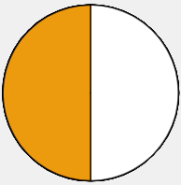
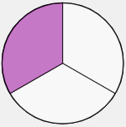
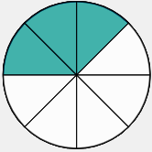
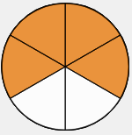
★ I have…  Who has…  $\frac{1}{8}$? | ★ I have…  Who has…  $\frac{1}{6}$ ? | ★ I have…  Who has…  $\frac{1}{4}$?
★ I have…  Who has…  $\frac{6}{8}$? | ★ I have…  Who has…  $\frac{5}{6}$? | ★ I have…  Who has…  $\frac{6}{6}$?

Fractions B1-B6: $\frac{1}{8}$, $\frac{1}{6}$, $\frac{1}{4}$, $\frac{6}{8}$,$\frac{5}{6}$,$\frac{6}{6}$
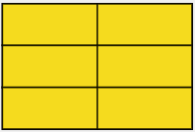
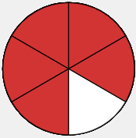
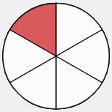
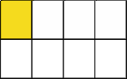
I have…  Who has…  $\frac{1}{3}$? | I have…  Who has…  $\frac{1}{2}$ ? | I have…  Who has…  $\frac{3}{8}$?
I have…  Who has…  $\frac{4}{6}$? | I have…  Who has…  $\frac{1}{1}$? | I have…  Who has…  $\frac{8}{8}$?

Fractions A7-A12: $\frac{8}{8}$, $\frac{2}{3}$, $\frac{3}{6}$, $\frac{5}{8}$, $\frac{7}{8}$, $\frac{2}{2}$
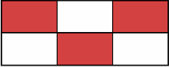
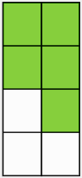
★ I have…  Who has…  $\frac{0}{4}$? | ★ I have…  Who has…  $\frac{2}{4}$? | ★ I have…  Who has…  $\frac{2}{6}$?
★ I have…  Who has…  $\frac{4}{8}$? | ★ I have…  Who has…  $\frac{3}{4}$? | ★ I have…  Who has…  $\frac{3}{3}$?

Fractions B7-B12: $\frac{0}{4}$, $\frac{2}{4}$, $\frac{2}{6}$, $\frac{4}{8}$, $\frac{3}{4}$, $\frac{3}{3}$
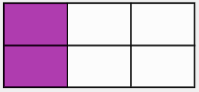
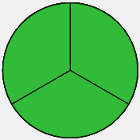
I have…  Who has…  $\frac{2}{3}$? | I have…  Who has…  $\frac{3}{6}$? | I have…  Who has…  $\frac{5}{8}$?
I have…  Who has…  $\frac{7}{8}$? | I have…  Who has…  $\frac{2}{2}$? | I have…  Who has…  $\frac{2}{8}$?

